Valencia College has an existing form (Exhibit 1) to request information regarding applications for admission and will serve as the template for the proposed form to request for information regarding the Bachelor of Applied Science in Computing Technology and Software Development (BAS CTSD) program, which is delineated in Exhibit 2. The form will include introductory text as well.

**Exhibit 1: Existing Form**

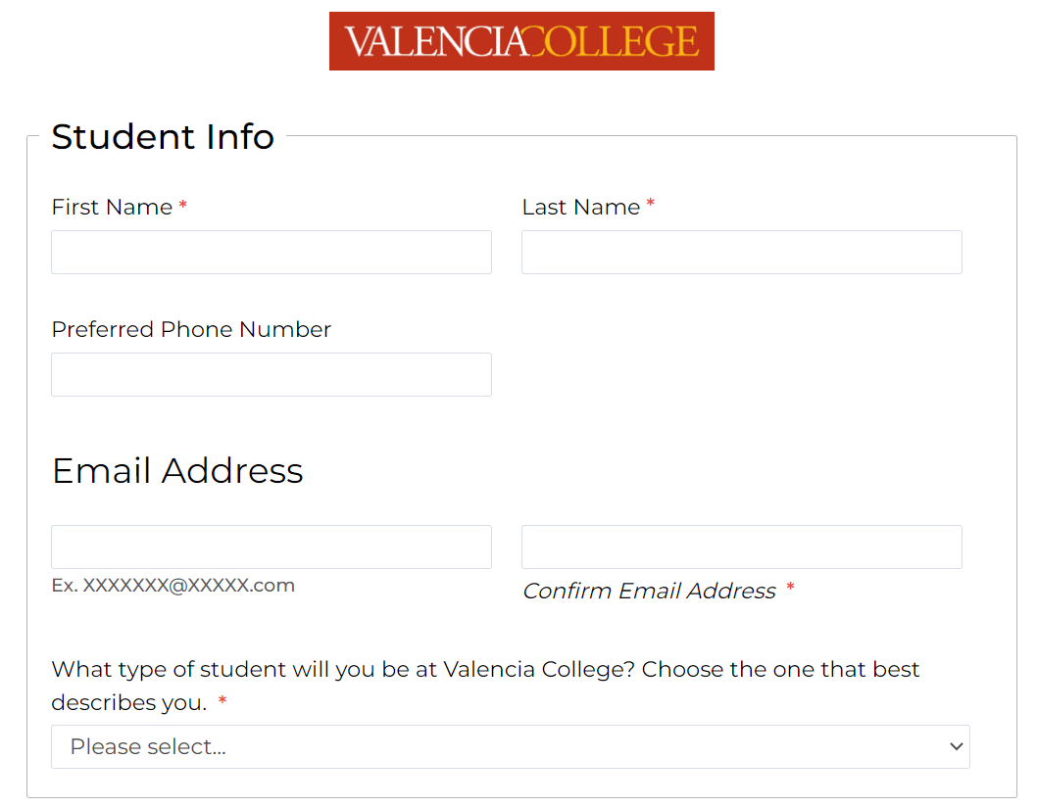

**Exhibit 2: Proposed Request for Information Form**



